www.hegartymaths.com or google hegartymaths
If you start typing John Spence our school will appear – just click on it and you will be taken to …
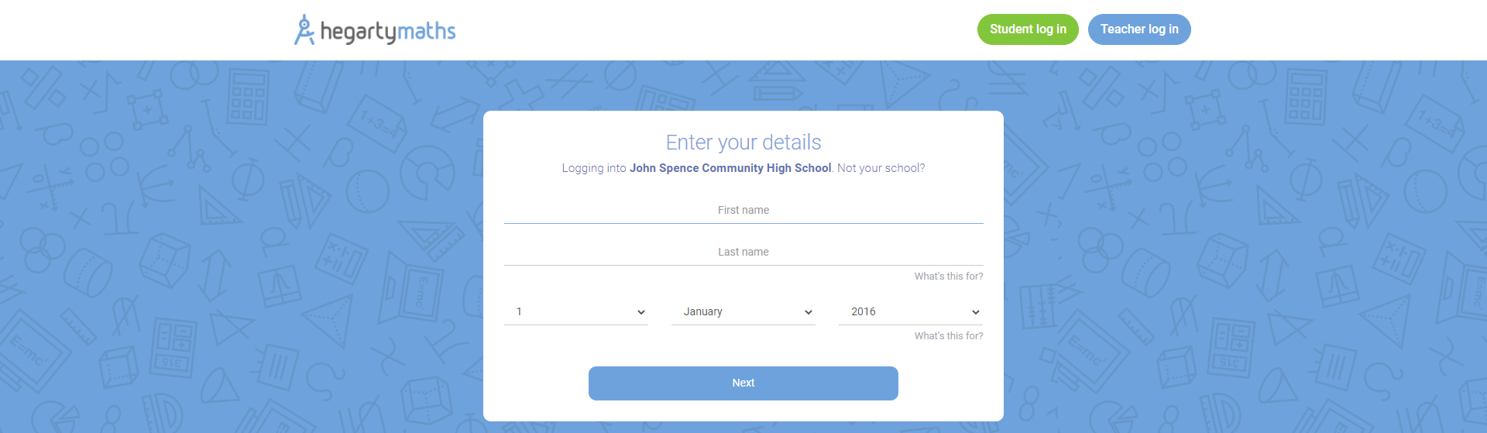
On this screen enter your name and date of birth. You will be taken to the following screen…
Make up a password that you will remember. You will then be taken to the task screen.
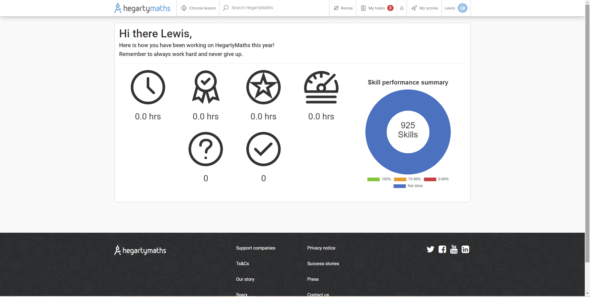
If you click on My Tasks you will be taken to your homework to complete
Click on a task to be taken to this work. You will find a video to watch telling you how to do the work. To do the work click on Do quiz.
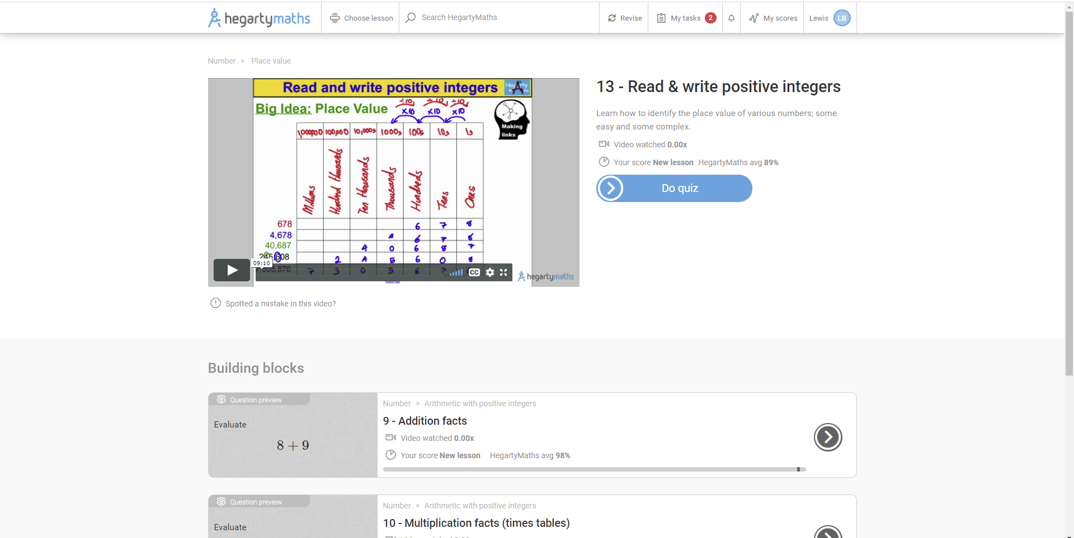

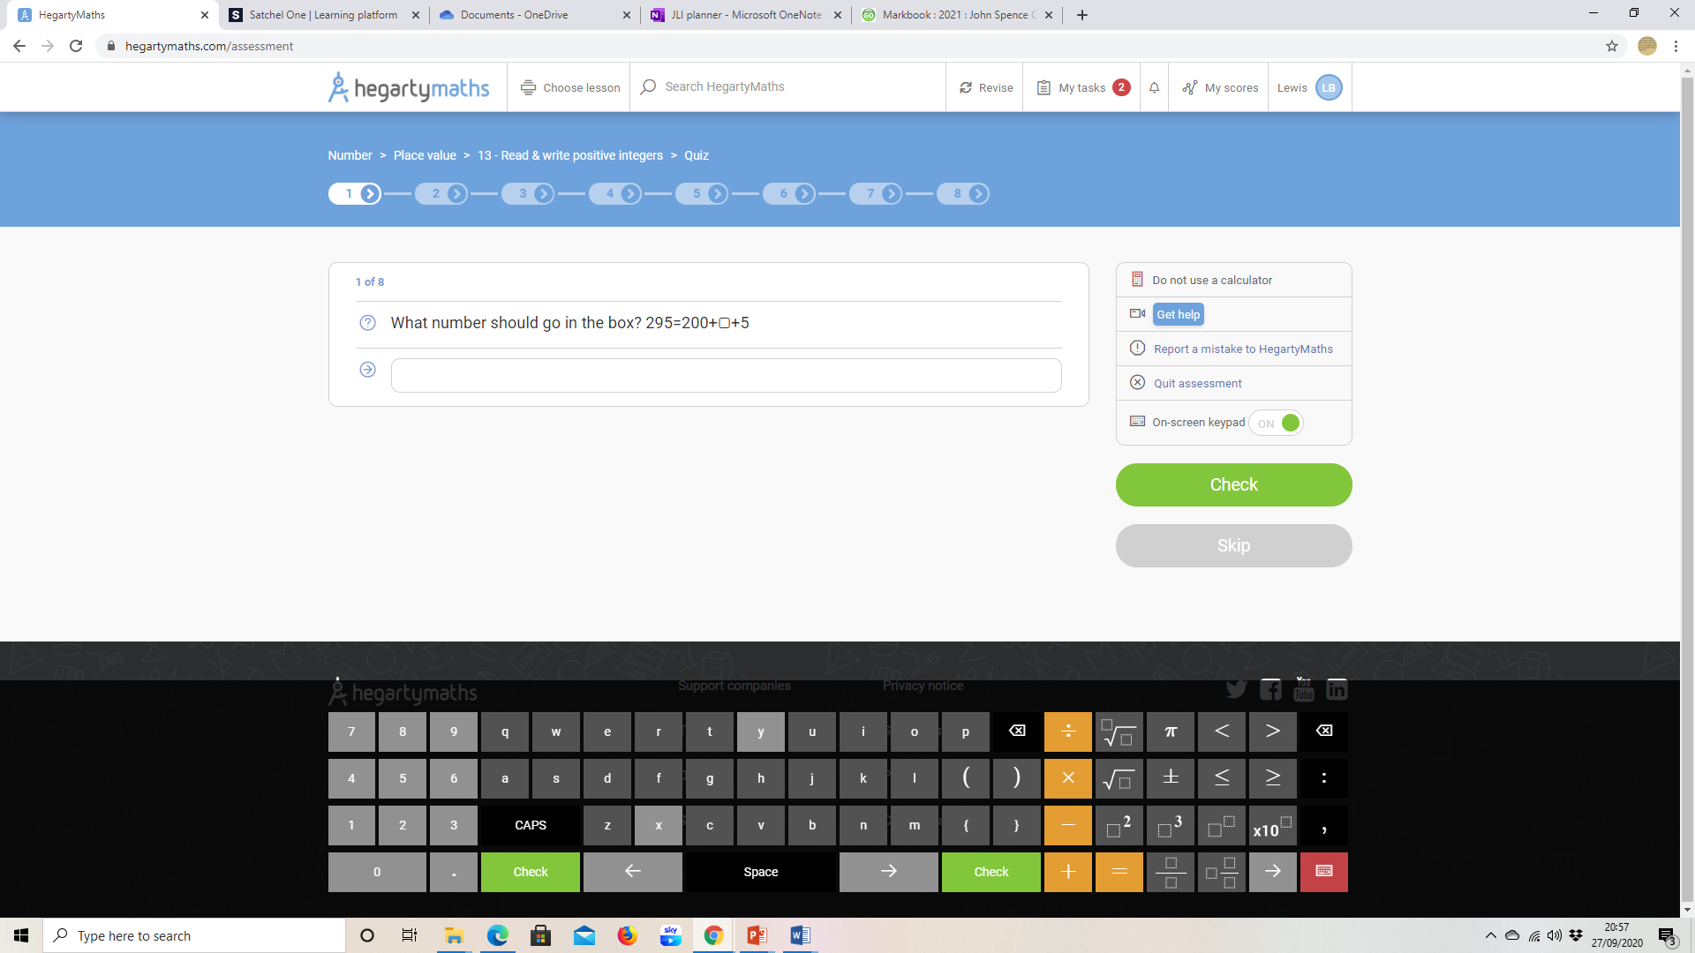
This is what a normal question screen looks like. You put your answer in this box. You can use your computer keyboard or the one shown at the bottom of the screen. If you are stuck click the Get help button and you will be taken to the correct place in the video to show you what to do.

