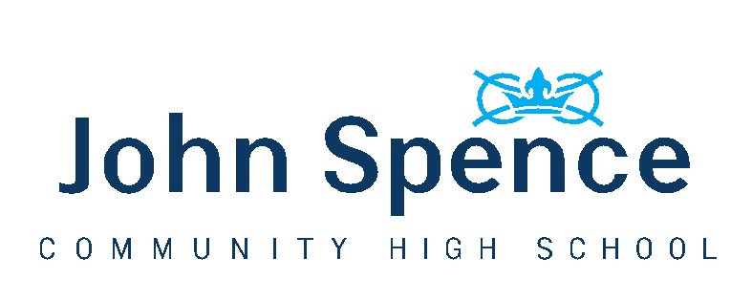
September Arrangements for Year 10
Our aim in September is to keep things as normal as possible and to keep everyone as safe as possible.
Our overall strategy is designed to minimise the risk of transmission of Coronavirus whilst delivering a full curriculum. Our approach is in line with the guidance published by the Government on 2nd July where it is made clear that risk remains low if students are grouped in bubbles, effective cleaning regimes are in place, everyone follows strict hygiene routines and distancing measures are in place.
Year 10 will be in a ‘bubble’ with Year 11 in school and remain in the Year 10/11 zone for all of their lessons apart from PE. Teachers will move between zones so that year group will have access to their full curriculum.
There will be a staggered start and end of the day to help minimise contact between students in different bubbles.
Start Date – Thursday 3rd September
Start Time – Students should aim to arrive in school at 8.45am and be in their form room by 8.50am
Entrance – Middle Stairwell Doors
School Day
 |  | Location
8.45am | Arrival | Enter via middle stairwell doors
8.50am | Registration | Form Room
8.55am | Period 1 | Year 10/11 Zone
9.55am | Period 2 | Year 10/11 Zone
10.55am | Break | North Yard (wet break in Dining Hall)
11.10am | Period 3 | Year 10/11 Zone
12.15pm | Period 4 | Year 10/11 Zone
13.15pm | Lunch | Dining Hall/MUGA (wet break in Dining Hall)
13.55pm | Period 5 | Year 10/11 Zone
3.05pm | End of Day | Exit via middle stairwell doors

Please note that the Scholars service has been moved by 5 minutes to accommodate the slightly later finish time.
Break & Lunchtime
Students will remain in their Year 10/11 bubble designated areas during break and lunchtime. Break time will be slightly shorter due to their later start and the need to move students back into the building as safely as possible.
Food will be available at break time for Year 10.
Hygiene
Every classroom has a wall mounted hand sanitiser unit. Students are required to use the sanitiser as they enter and leave every classroom.
Students should ensure they wash their hands thoroughly for 20 seconds when they go to the toilet.
If your child uses public transport, then they will need to use a face mask. Once off the bus/metro students should place the mask in a plastic bag inside their school bag for disposal or cleaning at home. They should have a clean mask for the return journey.
Considerate Distancing
The government guidance recommends that schools create bubbles to reduce the risk of transmission of the virus in schools. Students do not need to socially distance with one another in these bubbles but distancing measures do need to be maintained between staff and students due to the higher risk of adults developing severe symptoms and also because teachers will move between the different zones in the school. It should also be noted that we have a number of staff who are clinically vulnerable or clinically extremely vulnerable meaning that distancing is essential.
We are calling this Considerate Distancing in line with our Fit for Life attributes of being Resilient, Skilled and Considerate. To achieve this, teachers will have slightly different movement times around the building to students and each classroom will have a staff area. This will be an unusual experience for students as the teaching and support staff will maintain a 2 metre distance where possible meaning that the usual small group and individual interaction will not occur in the same way.
We have arranged classrooms, where possible to have forward facing desks to further minimise risk.
Students requiring support from our teaching assistants will be seated in an accessible area for staff so that they can support at a minimum of 1 metre plus distance.
The measures we have put in place will help to make sure that Considerate Distancing can work, but the measures will only be fully effective if students adhere to them. We will not tolerate students deliberately ignoring these measures or engaging in activities that put others at significant risk. Our Behaviour Policy has been updated to reflect this.
Toilets
Students are not allowed to go to the toilet during lessons unless there is a medical reason. Year 10 toilets will be the identified cubicles in the downstairs suite of toilets in the main building.
Uniform
Full uniform should be worn every day to school apart from days when your child has PE when they should wear their PE kit to school. This is to avoid use of the changing rooms as we are unable to put in place an effective cleaning regime in the short time between lessons.
Extra-Curricular
Extra-curricular activities will take place from September. These will take place within year group bubbles. Information will be shared with students and published on our website.

Support
Students with SEN will continue to receive appropriate support in lessons and in small groups, which will be broadly similar to what they have already experienced. Students who need support in class will be seated so that Support Assistants can work with them whilst maintaining a safe and considerate distance.
We recognise that some students may find the transition back into school difficult. There could be a wide variety of reasons for this and contact throughout the lockdown by your child’s Head of Year means that we do have a fair idea of who may need support. Our learning mentors and other pastoral staff will be in place and ready to support any students who may need it and we will use assemblies and for time as a wellbeing check in.
We will also be providing extensive programmes of catch up for all year groups. The majority of this will take place in lessons alongside some home learning, but some students may well receive additional support through various interventions that we have planned.

